**Assignment –5**

**Relational and Logical Operators.**

1) Write a query that will give you all orders for more than Rs. 1,000.

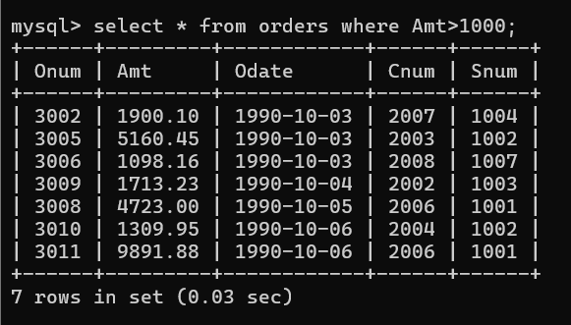

2) Write a query that will give you the names and cities of all salespeople in London with a commission above .10.

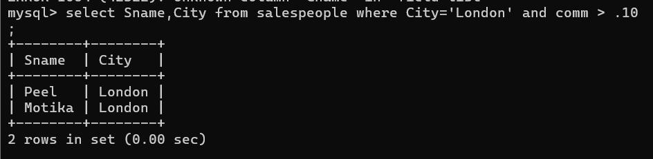

3) Write a query on the Customers table whose output will exclude all customers with a rating <= 100, unless they are located in Rome.

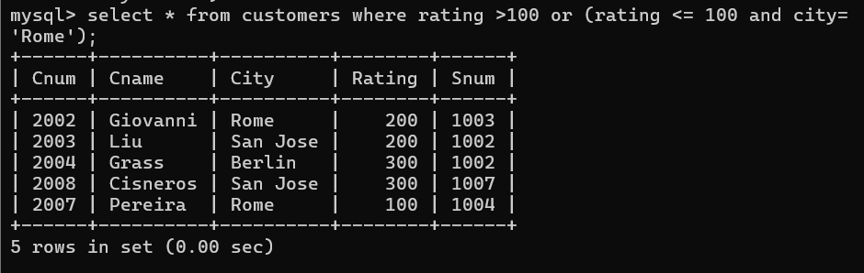

4) What will be the output from the following query? Select * from Orders where (amt < 1000 OR NOT (odate = ‘1990-10-03’ AND cnum > 2003));

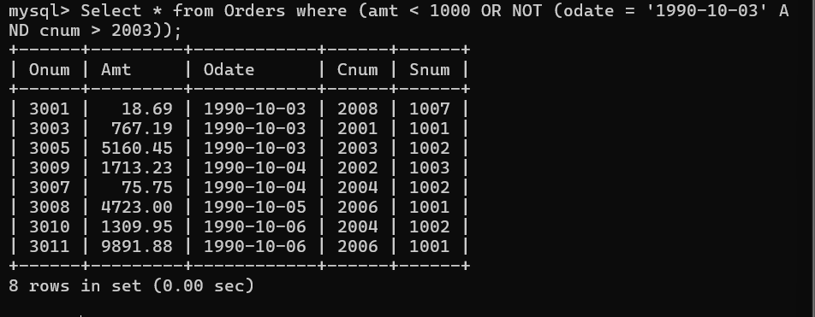  
  
the output of the query is all columns from orders table where amount is less than thousand or where Cdate is equal to 1990-10-003 and Cnum is grater than 2003.. so output only gets 8 rows out of 10 .

5) What will be the output of the following query? Select * from Orders where NOT ((odate = ‘1990-10-03’ OR snum >1006) AND amt >= 1500);

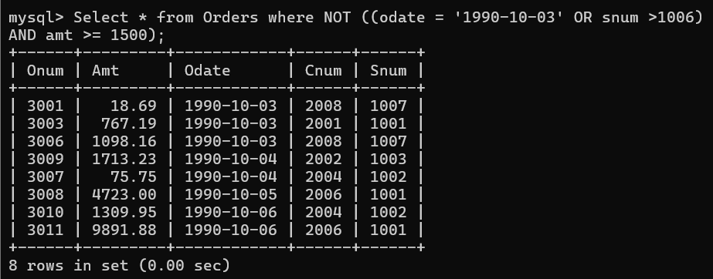

* Select Query select all column from orders Table where Rows are not odate as 1990-10-03 or snum is greater than 1006 and Amount is Greater than or equal to 1500;
* Its returns the 8 rows from the 10 rows of orders table. Which condition are satified

6) What is a simpler way to write this query? Select snum, sname, city, comm From Salespeople where (comm > .12 OR comm <.14);

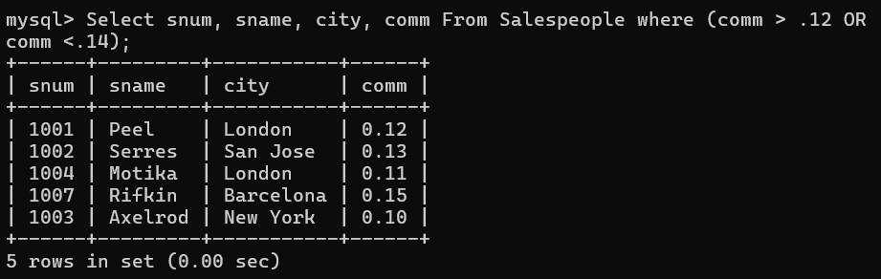

After simpler way -

